MEMM/CRF

Source: https://people.ischool.berkeley.edu/~dbamman/nlp20_slides/11_hmm_memm.pdf

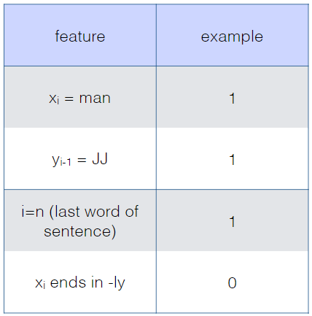
Maximum entropy Markov model (discriminative)
- Multi class logistic regression:
- Features over previous prediction and input
- Limitation: label bias since start states are not calibrated and may lead to incorrect predictions

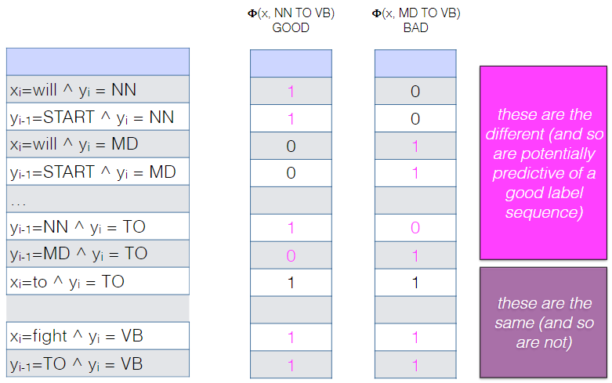
Conditional random fields model (discriminative)
- where which is the same feature vector used for MEMM
- Estimates probabilities using the entire sequence by summing individual features at each time step. Helps isolate global sequence features that have predictive power
- Advantage: no label bias and higher accuracy than MEMM
- Limitation: exponential complexity for each sequence at each gradient step and slow training. Can reduce to using forward algorithm

